**Day 04**

**Filters:**

Some commonly used filters are grep, sort, cut, paste ,head ,tail, wc, pg, more, tree

head and tail are used for runtime files like servers to get real time responses.

**find command :**

the find command is used to search a file.

The syntax for it is

find ./ -name [filename]



Hence it gives the files that starts with that particular name

**find . -type d** is the command used to search and display all directories in all subdirectories starting from current directory

**.** 🡪 start search from the current directory.

**-**type d 🡪 only matches directories so it excludes files

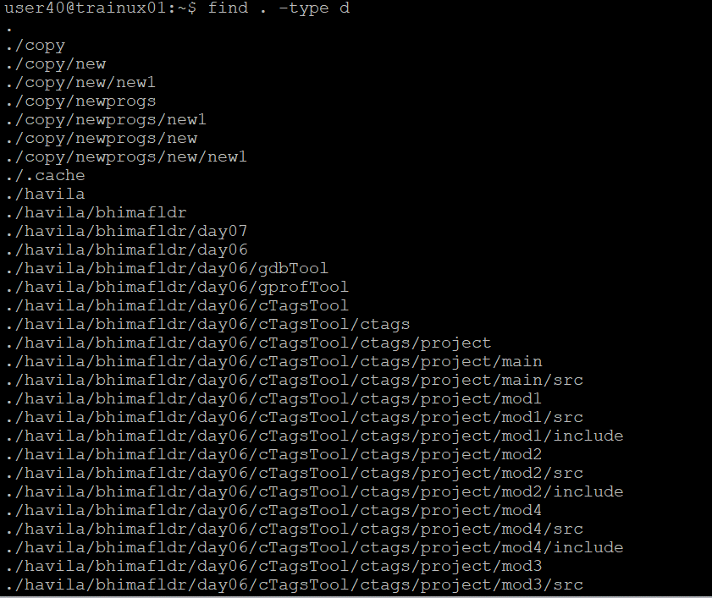

Even if you don’t remember the file name it can be searched by giving the first letter of the file with its extension as shown below

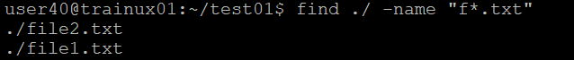

**Grep**

global search for regular expression and print utility,is the standard file searching and selection utility.

Used to search for a particular pattern of chars and display all the lines containing the pattern

Here the word world is searched by the grep command which is present in a particular file named file1.txt

When grep command with the pattern to search is given it searches in the file and highlights the word that is being searched .

So syntax is : grep<pattern><file name>

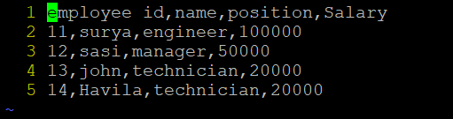

In the above employee file the grep command is used to get the pattern required for the user as shown below grep “5…$”employee.dat will display the pattern that starts with 5

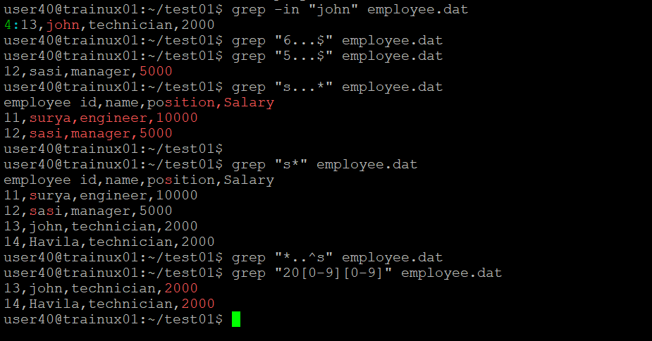

Some regular expressions

^- beginning of line

$-end of line

. ant single character

^… string beginning from any char after^ will be executed

[…] any one character from list

-i is the ignore case

-l only name of files with matching lines are displayed

-c print only

* ssh mean secured shell

**library creation in c programming**

**1.)static library (.a)**

The static library is a collection of object files.

**2.)shared library(.so)**

Shared library are not embedded into the executables but are loaded at runtime

The process time of static library is more than the shared library.

**3.)dynamic library**(loaded at run time )